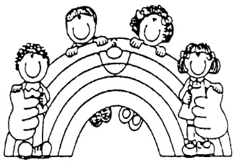
Rainbow Years Learning Ministry
7235 W 100 N
Shipshewana, IN 46565
1.260.768.7153
www.rainbowyears.org

Enriching the Lives of Children Through Dependable Christian Care

Items to Bring to RYLM
To help your child have a safe, comfortable, and fun time at RYLM, please make sure that the following items are here daily:
- Weather appropriate outerwear (coat, hats, gloves, boots, etc) – We go outside if the temperature is over 25 degrees and under 90 degrees.
- Extra clothes – we get messy sometimes, having an extra outfit or two helps us keep your child comfortable.
- Water bottle
- Comfort items – a blanket, pillow, stuffed animal – let’s make nap time easy.
- Diapering needs – please provide diapers, wipes, any creams needed to keep your child healthy and dry.
- Nutritional needs – please provide bottles and formula/breastmilk.
- Medications – you may provide pain relievers to RYLM to use with proper authorization forms and parent consent. We also ask that you send in sunscreen and bug spray. Lotion and chap stick is also permitted.
*Please be sure to have items labeled with child’s name.

